BETSSON GROUP

**Product Owner (Gaming)**

Vadim Kööp

Tallinn 2022

Contents

List of figures 3

1 Theoretical background 4

1.1 Brief 4

1.2 Supporting Information 4

1.3 Task 5

2. User stories 6

2.1 Features that are already implemented 6

2.2 Features that need to be implemented 6

3. Measuring the results of the new search function and its capabilities 7

4. Analysis of the search function of other betting platforms 8

4.1 Olybet search function 8

4.2 Optibet search function 9

4.3 Bet365 search function 10

4.4 Betsafe search function 13

4.5 Analysis conclusions 14

5. Implementation of the MVP for the search function 15

5.1 Minimum viable product and contents 15

5.2 Minimum viable product framework 16

5.3 Further stages of improvement 16

6. Go to market plan 17

References 18

# List of figures

Figure 1. Olybet search design. 8

Figure 2. Olybet search game by the word "Wild". 8

Figure 3. Optibet search design. 9

Figure 4. Optibet search game by the word "Wild". 9

Figure 5. Bet365 home page search design. 10

Figure 6. Bet365 all games page search design. 11

Figure 7. Bet365 the first opening of the search bar. 11

Figure 8. Bet365 search game by the word "Wild". 12

Figure 9. Betsafe search design. 13

Figure 10. Figure 10. Betsafe search game by the word "Wild". 13

Figure 11. Minimum viable product framework. 16

# 1 Theoretical background

With such a vast portfolio, a key user challenge we are constantly looking to address is how we can make it as easy and quick as possible for players to find the games they are interested in. One of the key features in addressing this challenge is the search function, which allows players to find games they are looking through using search terms.

## 1.1 Brief

In this fictitious scenario, we do not currently offer a **search** **function** on our brands. Our players are able to “**favourite**” a game for **quick** **access** and we also prominently **display** the **games** **recently** **played** by the player. However, the search function has emerged as the most asked-for feature by our players from user research and feedback. In particular, we are seeing that:

* New players especially are **struggling** to find certain games they want to play, leading to a **significant** **number** to **drop** **off** **without** **playing**.
* The customer satisfaction scores (and other key **metrics**) of returning players has been **decreasing** over the past months. Although they are able to **quickly** **find** games they have **already** **played** or **marked** as a **favourite**, they often **struggle** to find **other** **games** they are interested in **unless** these are prominently **displayed** in the product.

For these reasons, the introduction of a **search** **function** has been established as the number **1** **priority** for the Gaming team.

## 1.2 Supporting Information

In order to prepare you for the task, the Product Manager has provided you with the following information:

* Since **80%** of our business comes from mobile, the priority is to launch this feature for **mobile users** over desktop users.
* From user research and feedback, we understand that whilst players obviously expect the search function to allow them to **search** by the **name** **of** **a** **game**, a good number (approx. 20%) would also like to search for games by **game** **studio**.
* The games on offer can vary by market (i.e. the player’s **country** **of** **registration**) due to the different legislations at play. It is important that the **search** **function** only **returns** **games** that are **available** for the **player** **to** **play**.
* Popular games spawn a number of variants. For example, we have a large number of different **roulette** and **blackjack** **games** – **one can expect over 50 games** to be **returned** **for** **such** **searches**. On a smaller scale, the popularity of **Starburst** has spawned two other games: “**Starburst** **XXXtreme**” and “**Starburst** **Slingo**”.
* On the advice of the technical architects, a **global** **search** **function** that **covers** **both** **sports** **betting** and **games** **of** **chance** has been deemed **unfeasible** due to the **separation** and **difference** in the **data** **structures**. Therefore, your focus will be on delivering a **search** **function** for that covers **games** **of** **chance** and **not** **sports** **betting**. **The search function for sports betting will be a separate function built within the sports betting product.**

## 1.3 Task

As a Product Owner in the Gaming area, you have been asked to take the lead on **introducing** the new **search** **function**. For the purposes of this task, you are being requested to prepare and present the following:

1. A proposed feature set for the search function, covering both core **capabilities** and your **own** **ideas**. This can be considered as an initial product discovery exercise where you can research competitors and use your own experience and creativity to come up with ideas and define the epics.
2. A definition of the **MVP** for the search function and what this will encompass, including an explanation for your reasoning. You may additionally describe **subsequent** **phases** for **enhancing** the search function post-MVP.
3. **User** **stories** with **detailed** **acceptance** **criteria** for the **core** **search** **capabilities**; i.e. how the user can search and how the search **results** are **presented**. You are encouraged to prepare **wireframes** to **complement** the **user** **stories**.
4. A go-to-market plan for launching the search function and how you would **measure** its **success**.

# 2. User stories

In this section, the author describes the main needs of the customers. Since in this task the main goal is to implement the search function, then only those parameters that are associated with this task would be describe.

## 2.1 Features that are already implemented

- As a customer, I want to be able to use the favourites/quick access feature for the game.

- As a customer, I want to be able to use the recently played feature for the games.

## 2.2 Features that need to be implemented

- As a customer, I want to be able to use the desktop version of the service.

- As a customer, I want to be able to mobile version of the service.

- As a customer, I want to have the opportunity to use the search function.

- As a customer, I want to have the opportunity to search by the name of the game.

- As a customer, I want to have the opportunity to sort games by the game studio.

- As a customer, I want to have the opportunity to sort games by type of game “game of chance”.

- As a customer, I want to be able to find games that match my interests.

- As a customer, I want to be able to see the correct search results and return games that are available depending on the region of registration.

- As a customer, I want to be able to see the correct search results and return games that are available depending on the customer’s location. (?)

# 3. Measuring the results of the new search function and its capabilities

During new functional releases, the main metrics should be used to track results. Understanding the results provides a good opportunity to orient ourselves in our product, and provide the best user experience to your customers, thus we can avoid unnecessary problems in the future.

Metrics by which to evaluate our results:

1. Gross gaming revenue – the amount of money a **service** **made** over a certain **amount of time**.
2. NGR to deposits - a ratio that shows how **much** **money** was **made** from **deposits** made by customers over a certain amount of time.
3. Bets to deposits - show how much **money** **players** **actually** **bet**.
4. Value for the long term - shows how **much** **money** a customer has **put** **into** over the time they’ve been on the platform.
5. The churn rate - the number of people **who** **stopped** **playing** compared to the number of people who have been playing for a certain amount of time.
6. The average revenue per user - shows how much money a **single** **casino** games player **makes**.
7. A number of sessions were played.
8. Session time spent in games by players.
9. A small questionnaire with choices of answers and comments about the new functional release. [1]

# 4. Analysis of the search function of other betting platforms

Before developing any new product, author has explored the current market, as well as analyzed different companies products, and also realized the pros and cons of today's products on the market in order to understand and get a good idea about the own product.

## 4.1 Olybet search function

Before starting to search for a game, the page displays the different categories of services and categories of the games.

There is an option to change the screen to black or white.

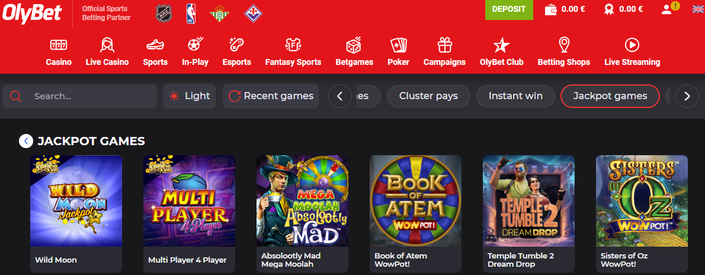

*Figure 1. Olybet search design.*

Searching by the word "Wild" returned 8 search results. The number of search results is not displayed. Next to each game, a volatility level has been added.

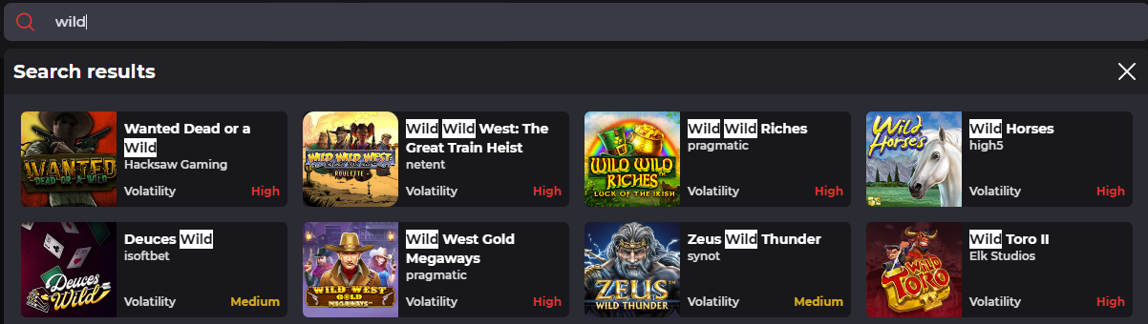

*Figure 2. Olybet search game by the word "Wild".*

## 4.2 Optibet search function

Before starting to search for a game, the page displays the different categories of service, categories of the game, recently played label, popular label, new label, all labels and e.t.c. which initially provides an opportunity for users to find the game they need.

List of initial game categories added to the page: popular, new, exclusive, all, daily, jackpots, megaways, games of nerve, jackpot, bonus buy, christmas, evolution first person, drops & wins, table games.

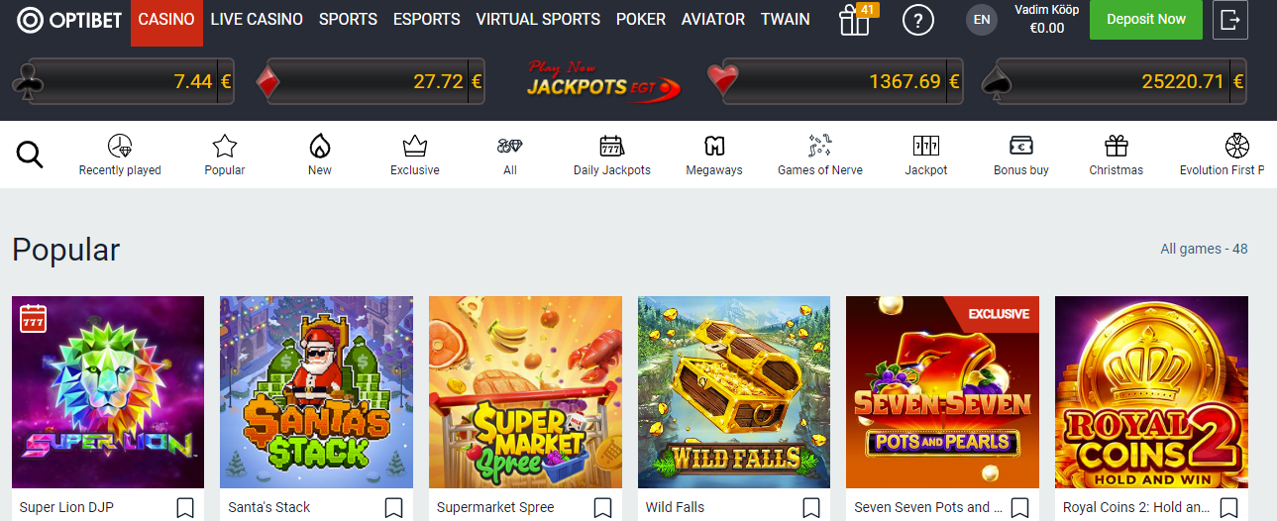

*Figure 3. Optibet search design.*

Searching by the word "Wild" returned 225 search results.

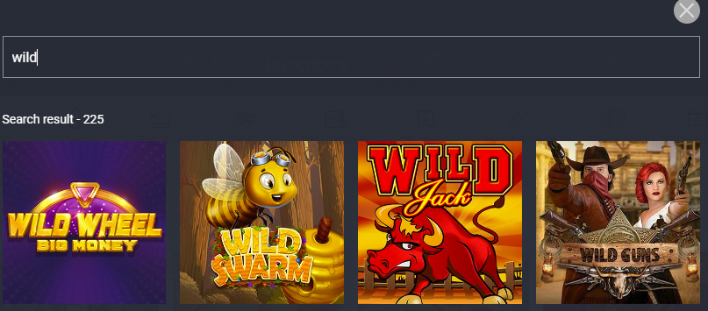

*Figure 4. Optibet search game by the word "Wild".*

## 4.3 Bet365 search function

Before starting to search for a game, the page displays the different categories of the game, which initially provide an opportunity for users to find the game they need.

List of initial game categories that are mapped to the page: recommended, discover what's new, original games, megaways, board and card games, jackpots, all games.

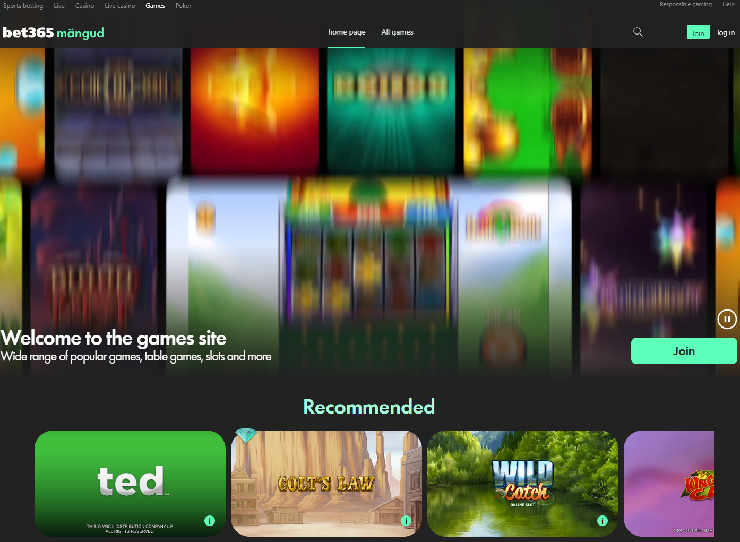

*Figure 5. Bet365 home page search design.*

Before starting to search for a game, the page displays the different categories of the game, which initially provide an opportunity for customers to find the game they need.

List of initial game categories that are added to the page: new, original games, popular, video slots, board and card games, megaways, jackpots, and other games.

Also, for each game, there is a window with a brief description where is displayed next information: rollers, patterns, RTP, changeability level, functions, explanations of RTP and volatility.

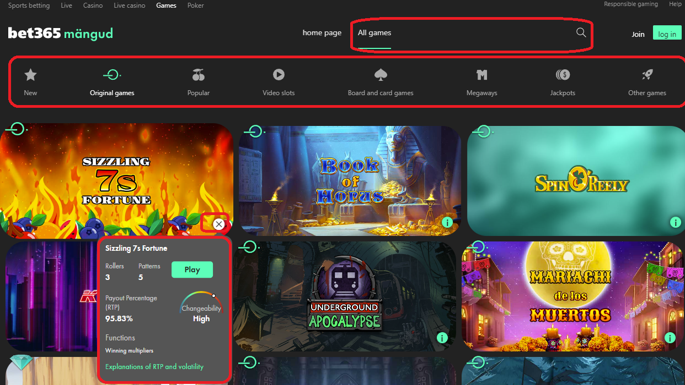

*Figure 6. Bet365 all games page search design.*

When the search is activated, it is possible to enter text using a microphone, as well as the following categories of the game: book of, megaways, and age of the gods.

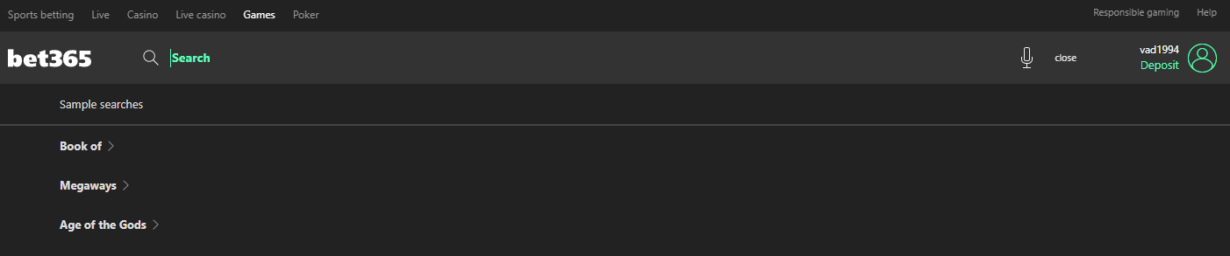

*Figure 7. Bet365 the first opening of the search bar.*

Searching by the word "Wild" returned 13 search results. The number of search results is not displayed.

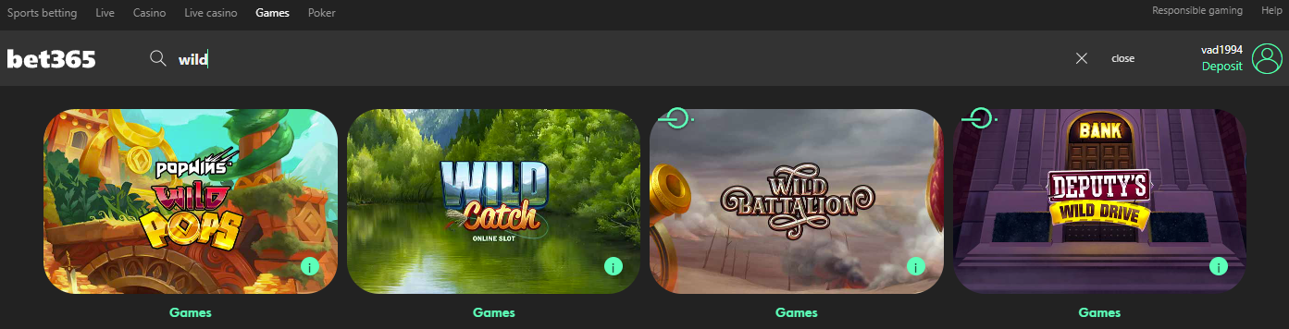

*Figure 8. Bet365 search game by the word "Wild".*

## 4.4 Betsafe search function

Before starting to search for a game, the page displays the different categories of service, categories of the game, hide/open categories label, filter by alphabetic and popularity, closing and opening favourite and recently played menu.

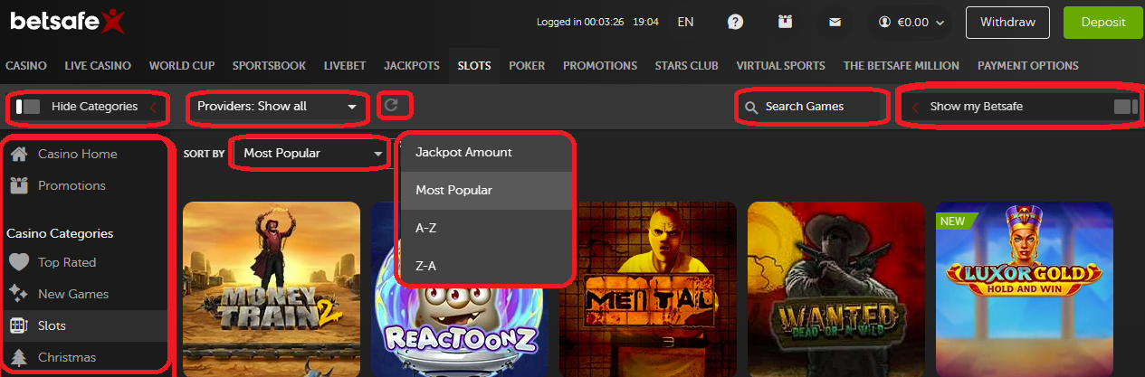

*Figure 9. Betsafe search design.*

In this search, the filter for choosing the type of game, provider and search results is implemented.

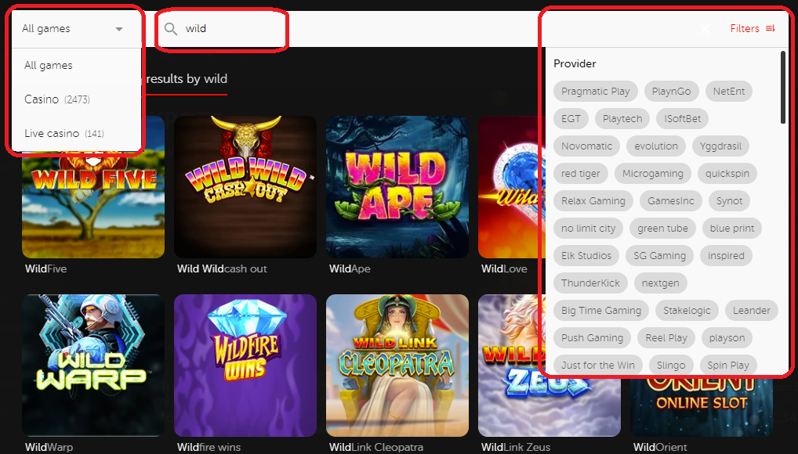

*Figure 10. Figure 10. Betsafe search game by the word "Wild".*

## 4.5 Analysis conclusions

Basically, the above betting platforms have a similar structure. They contain the following menus, functions and sorting:

* Light/dark display.
* Menu of the betting services/games.
* Categories.
* Search function.
* Additional game search for similar queries.
* Search results.
* The total number of results.
* Game description.
* Sort by provider.
* Sort alphabetically.
* Sort by popularity.
* Menu of recently played and favourite.
* Search сleanup.
* The minimize function for secondary windows.
* Language.

The author likes the most how the search engine is implemented on the Betsafe website. In author’s opinion, the search engine is designed very logically and does not require additional efforts from customers, thereby providing them with the best user experience.

# 5. Implementation of the MVP for the search function

Based on the user stories in modules 2.1 and 2.2, the author describes the basic needs of the customers and implements a minimum viable product with a search function.

The author already knows that developer has implemented the following functions:

* Favourite games.
* Recently played games.

The author is also aware of the following factors:

* Minimum viable product condition.
* Customers are struggling to find the games and the games that might be interesting for them, because of the displaying issue.
* Priority is on the mobile version (80% of customers).
* Customers want to have the option to search by the name of a game (80% of customers).
* Customers want to have the option to search by the game studio (20% of customers).
* Customers should see the games that are only available to them (regional laws).
* During the serch process, customers want to see additional games with the same keywords.
* A search of the sports betting and chance games would be implemented separately (focus on games of chance, not sports betting).

## 5.1 Minimum viable product and contents

The minimum viable product would contain the following features:

* Favourite game menu.
* Recently played games menu.
* Search function by the name of games of chance.
* Additional display of the games of chance by main keywords.
* A function that will read the player's registration data and display only the games available to customers.

The main focus will be on the mobile version.

## 5.2 Minimum viable product framework

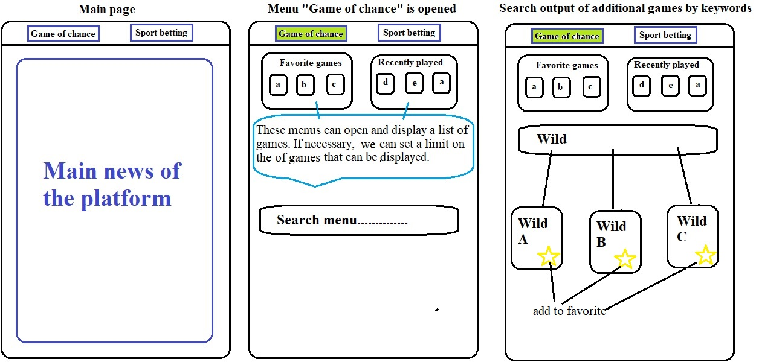

*Figure 11. Minimum viable product framework.*

## 5.3 Further stages of improvement

When the product is launched LIVE and the first data (3. Measuring the results of the new search function and its capabilities) would be available, future updates can be implemented.

First of all, author would implement the missing functionality (5. Implementation of the MVP for the search function), later the functionality (4.5 Analysis conclusions) could be considered and implemented in the main product.

# 6. Go to market plan

During the new update release, the following actions could be done:

* Possibility of notifications about found bugs by customers.
* User notifications via website or email about a new updates.
* Creating a questionnaire with the choice of answer on the topic of a new functional release for the customers.
* The launch of all kinds of events, where customers have to try out new functionality. After finishing the new challenges, customers receive rewards, that can be used in the games of chance.

When the first data is known then the measures (3. Measuring the results of the new search function and its capabilities) can be analyzed and future works can be planned.

# References

[1] The importance of key performance indicators in an online gambling business 2022. [Online] <https://www.tutorialspoint.com/java/java_regular_expressions.htm> - (Accessed 12.12.2022)

[2] OlyBet - online casino and sports betting. [Online]  
<https://www.olybet.ee> – (Accessed 12.12.2022)

[3] Optibet - online casino and sports betting. [Online]  
<https://www.optibet.ee> - (Accessed 12.12.2022)

[4] Bet365 - the world's most popular online bookmaker. [Online]  
<https://www.bet365.ee> - (Accessed 12.12.2022)

[5] Betsafe - sportsbook with live and in play betting, Casino and Live Casino. [Online]  
<https://www.betsafe.ee> - (Accessed 12.12.2022)